Otahuhu RSA April 2025 Newsletter
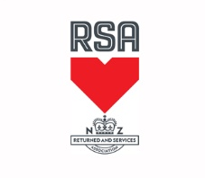
Victoria Arcade
435 Great South Rd
Otahuhu
Poppy collectors are still urgently needed for Wednesday 23 April at Auckland International Airport Terminal.
Thank you to those who have already volunteered.
Please contact Lesley on 0274581471 or email mlguptill@xtra.co.nz.
Anzac Day
Dawn Service is being held at 6.30 am in the Otahuhu Cemetery. Helpers needed.
Breakfast back at the Otahuhu Club afterwards. This costs $18 and tickets need to be prepaid before that day. There are only a limited number of tickets available.
Civic Service at the Monument is at 9.15
Helpers are needed especially someone who knows flag etiquette.
After the service we will make our way back to Otahuhu Club for people to meet and share refreshments
100 years celebration.
Cost for the weekend will be $110.
Registration will be online soon.

